Production Planning and Execution (PP) Case Study
This case study explains an integrated production planning and execution process in detail and thus fosters a thorough understanding of each process step and underlying SAP functionality.

Product  SAP ERP  G.B.I.  Release 6.07  Level  Undergraduate  Graduate  Beginner  Focus  Production Planning and Execution  Authors  Bret Wagner  Stefan Weidner  Version  2.40  Last Update  April 2015 | MOTIVATION  The data entry requirements in the production planning exercises (PP 1 through PP 6) were minimized because much of the data already existed in the SAP system. This stored data, known as master data, simplifies the processing of business transactions. Examples for this were material master data, bills of materials, and routings.  In this case study, we will create consumption values for a finished product to plan and process a complete manufacturing cycle. |  | PREREQUISITES  Before you use this case study, you should be familiar with navigation in the SAP system.  In order to successfully work through this case study, it is not necessary to have finished the PP exercises (PP 1 through PP 6). However, it is recommended.  NOTES  This case study uses the Global Bike Inc. (G.B.I.) data set, which has exclusively been created for SAP UA global curricula.



 | Process Overview
Learning Objective Understand and perform a manufacturing process cycle Time 140 min
Scenario In order to process a complete manufacturing process you will take on different roles within the GBI company, e.g. production supervisor, shop floor worker and plant manager. Overall, you will be working in the Materials Management (MM) and the Production Planning and Execution (PP) departments.
Employees involved Jun Lee (Production Supervisor)
Hiro Abe (Plant Manager Dallas)
Lars Iseler (Production Order Worker)
Susanne Castro (Receiving Clerk)
Sanjay Datar (Warehouse Employee)
Michael Brauer (Shop Floor Worker 4)
Jamie Shamblin (Cost Accountant)
Before you can start forecasting demand for your touring bike product group changes in the material master record of the bikes need to be maintained.  Afterwards you will create a 12-month sales and operations plan (SOP) for your product group, receive the production relevant goods from the storage location and issue goods to the production order.  In the last steps the completeness of the production is confirmed, produced goods are received in the storage location and costs assigned to the production order are reviewed. |  | Process description
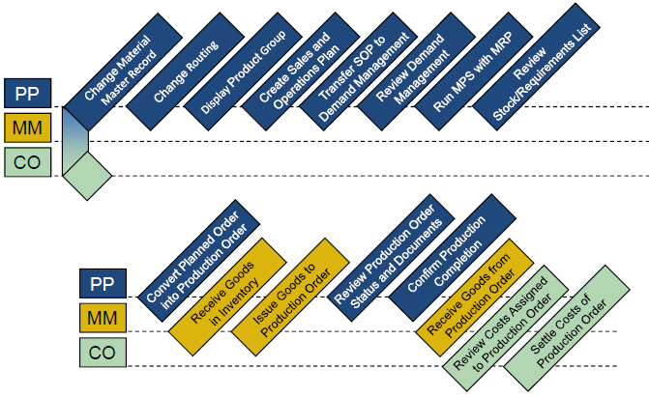

 | Step 1: Change Material Master Record
Task Prepare a material master record for Demand Planning. Time 20 min
Short Description In order to plan GBI’s deluxe touring bikes (black, silver and red) prepare their material master records by changing the MRP 3 and Forecast view.
Name (Position) Jun Lee (Production Supervisor)
To change a material’s view, follow the menu path:  Logistics ► Production ► Master Data ► Material Master ► Material ► Change ► Immediately |  | Menu path
In the Material field, find and select your red Deluxe Touring bike first.
If you do not remember its material number, position your cursor in the Material field and click on the search icon or press F4. Make sure you are on the Material by Material Type tab. Select Material Type Finished Product (FERT) and enter *### in the Material field. Remember to replace ### by your three-digit number given by your instructor, e.g. *005 if your number is 005. Then, press Enter and select the red Deluxe Touring bike with a double click. |  | F4  Finished Product  *###
When your material number (DXTR3###) is entered in the Material field, click on or press Enter. |  | DXTR3###
On the following screen, select MRP 3 and Forecast. |  | MRP 3, Forecast
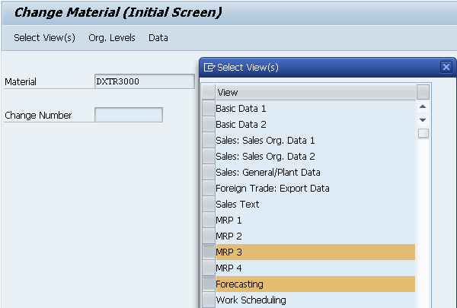
Then, press Enter or click on . The following screen will appear.
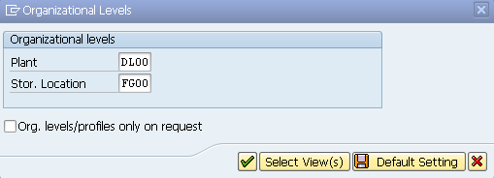
Find and select the GBI manufacturing facility in Dallas (DL00). Then, enter its Finished Goods Stor. Location (FG00). Press Enter or click on . |  | DL00  FG00
In the MRP 3 view, enter Strategy group 40 (Planning with final assembly), Consumption mode 1 (Backward consumption only) and Bwd.consumption per. 30. |  | 40  1  30
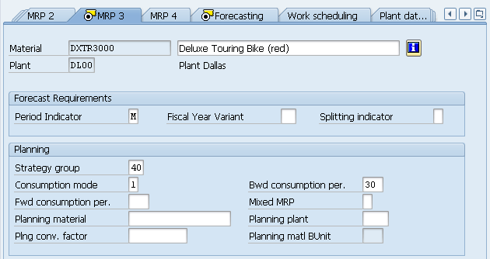
Click on to continue to the forecasting tab. Then, press Enter to acknowledge the warning message to check the consumption periods.
On the Forecasting tab, select Initialization pds 12, uncheck Reset automatically, check Param.optimization, select Optimization level F (Fine), Alpha factor 0.20, Beta factor 0.10, Gamma factor 0.30, and Delta factor 0.30.  Compare your entries with the screen capture shown below. |  | 12  Reset automatically  Param.optimization  F  0.20 0.10  0.30 0.30
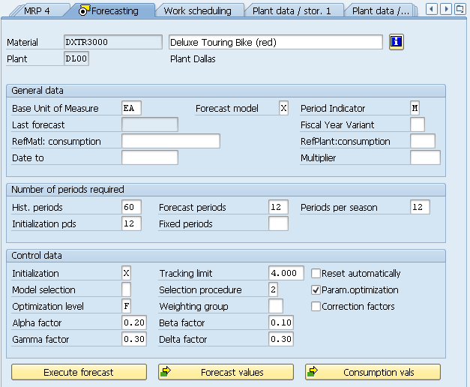
Historic consumption values already have been entered into the GBI system. You can view them on the Forecasting tab, select . If you do not see the Total consumption column, press on . Within the table you will see the Total Consumption for the periods 04.2010 to 03.2014. These values form the base for later forecasts within this case study.
Please note that within a productive system these values would have been updated based on the goods moved out of storage.
Click on to return to the overview.
Click on to save your entries for the red bike.
Repeat the same procedure for the silver and the black deluxe touring bike material master. Start with the silver bike (DXTR2###), then modify the black bike (DXTR1###). |  | DXTR2###  DXTR1###
Click on the exit icon to return to the SAP Easy Access screen.

 | Step 2: Change Routing
Task Change a routing for a finished good. Time 15 min
Short Description Change the routing for your red Deluxe Touring bike.
Name (Position) Jun Lee (Production Supervisor)
After the operational steps are laid out, the components must be allocated to the individual operations. This is a progressive process where each operation builds off the materials that entered production in the previous operations. |  | Component allocation
To change a routing, follow the menu path:  Logistics ► Production ► Master Data ► Routings ► Routings ► Standard Routings ► Change |  | Menu path
Enter the material number for your red Deluxe Touring bike (DXTR3###). In the Plant field, enter GBI’s Dallas plant number (DL00). Please ensure that the Group field is empty. Then, press Enter or click on . |  | DXTR3###  DL00
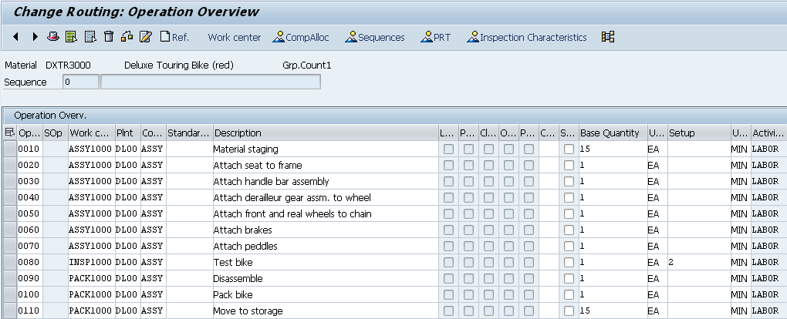
Choose and select the following two materials.
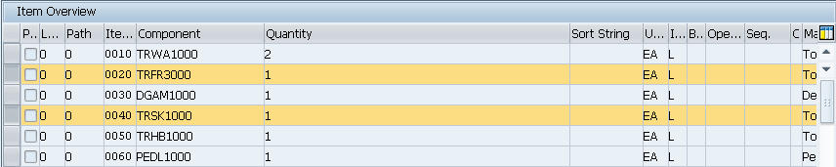
Once you have selected the red touring frame (TRFR3###) and the touring seat kit (TRSK1###), choose . |  | TRFR3###  TRSK1###
In the following screen, in the Oper./Act. field enter operation 0020 and press Enter. Back on the Material Component Overview screen, you see that now both components have been assigned to operation 0020. |  | 0020
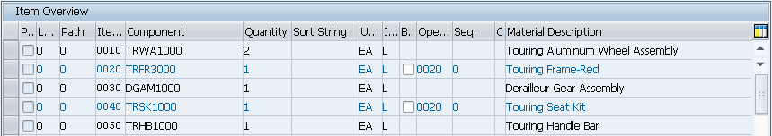
Repeat the same process for the other components and assign them to operations as shown below. |  | TRHB1###  TRWA1###  DGAM1###  CHAN1###  BRKT1###  PEDL1###  WDOC1###  PCKG1###
  Component | Operation
  TRHB1### (touring handle bar) | 0030
  TRWA1### (touring aluminum wheel assembly) | 0040
  DGAM1### (derailleur gear assembly) | 0040
  CHAN1### (chain) | 0050
  BRKT1### (brake kit) | 0060
  PEDL1### (pedal assembly) | 0070
  WDOC1### (warranty document) | 0100
  PCKG1### (packaging) | 0100
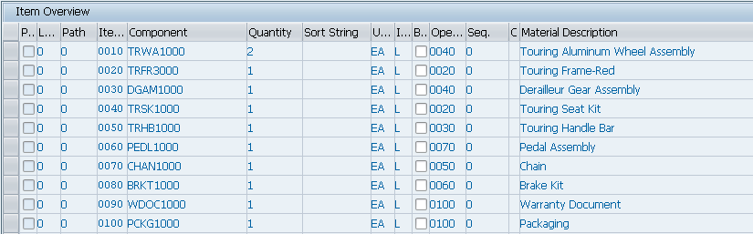
Click on and save your entries with .
Click on the exit icon to go back to the SAP Easy Access Menu.

 | Step 3: Display Product Group
Task Display a product group. Time 5 min
Short Description Display the product group (product family) for all your Deluxe Touring bikes.
Name (Position) Jun Lee (Production Supervisor)
A product group (product family) supports high-level planning. This way, it is not necessary to delve into the minutia of creating planning forecasts for every material in the company. |  | Product group
To display the deluxe touring bike product group, follow the menu path:  Logistics ► Production ► SOP ► Product Group ► Display |  | Menu path
In the Display Product Group: Initial Screen, in the Product group field find and select your group for deluxe touring bikes. In order to do so, press the search icon (or pressed F4), enter ###* in the Material description field. Remember to replace ### with your three-digit number, e.g. enter 009* if your number is 009. |  | ###*
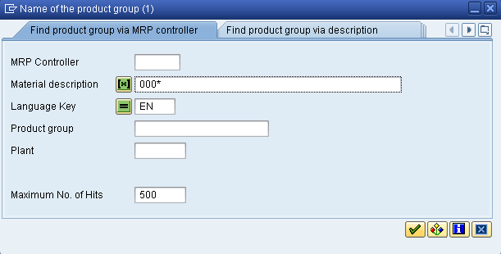
Then, press Enter or click on to display the search results. You should see five product groups already defined for your set of material master data (compare with the screen shown below).
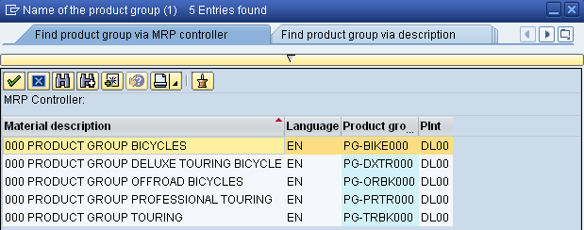
Double-click on the line for deluxe touring bicycles to select the group.
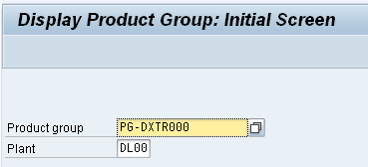
Now that the correct product group (PG-DXTR###) is filled in, make sure that Plant DL00 is entered. Then, press Enter to display the product group details. |  | PG-DXTR###  DL00
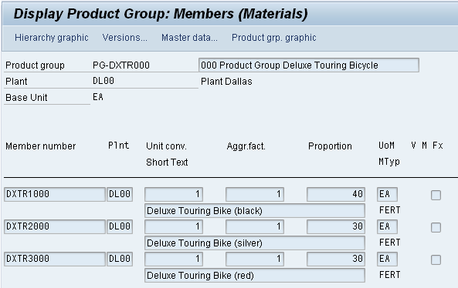
On this screen you can see that this product group defines proportions for three different bikes: the black, silver and red deluxe touring bike. For the black bike a share of 40% will be considered and 30% for the silver and the red bikes each.
Click on the exit icon to return to the SAP Easy Access screen.

 | Step 4: Create Sales and Operations Plan
Task Create a sales and operations plan for a product group. Time 20 min
Short Description Create a 12-month sales and operations plan (SOP) for your product group.
Name (Position) Jun Lee (Production Supervisor)
A sales and operations plan (SOP) is a planning tool used to consolidate data for forecasting future sales and production levels as well as the methods needed to meet those requirements. In this task, our SOP will be based on historical consumption values taken from a fixed period. This is in contrast to forecasting within a real life system which would base the prediction on previous periods and their respective consumption. |  | Sales and operations plan
To create an SOP, follow the menu path:  Logistics ► Production ► SOP ► Planning ► For Product Group ► Change |  | Menu path
Make sure that Product group PG-DXTR### and Plant DL00 are entered. Then, select . Record the version number: A00 |  | PG-DXTR###  DL00
In the system menu, select:
Edit ► Create sales plan ► Forecast…
Select Period intervals, Forecast from current period/current year to previous period/next year, Historic Data from 04/2010 to 03/2014, Forecast execution Aut. model selection. Compare your screen with the one below before clicking on . |  | Period intervals  current period/current year  previous period/next year  04/20140  03/2014  Aut. model selection
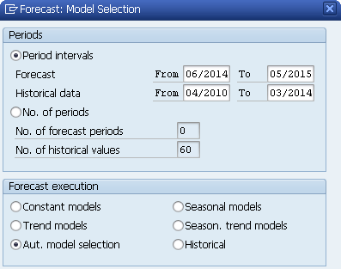
If needed, click on and continue through warning messages.
The system selected Trend and season. Click on .
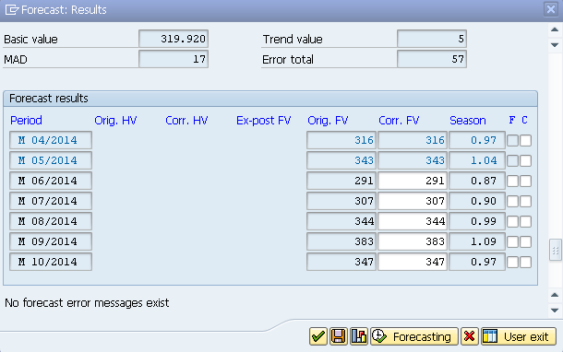
You can see that the system tested and found Seasonal and Trend tendencies in the past consumption data and has applied a Seasonal Trend Model.
Click on (Copy and Save). The sales forecast is copied into your Sales and Operations Plan.
As Target day’s supply enter 5 for each forecasted period (a total of 12 months). |  | 5
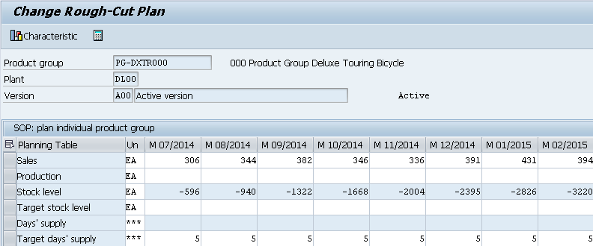
In a production plan, you plan the quantities you need to produce in order to meet your sales plan. The system then calculates stock levels and days’ supply for each period on the basis of the sales and production quantities and any target data. There are several different planning strategies available, which differ in the production values and the stock level changes.
As the SOP is a high level planning, discrete production values are not necessary. The SAP system calculates discrete numbers once the SOP is transferred to the Demand Management.
In the system menu, select:
Edit ► Create productn plan ► Synchronous to sales
Note the change in the Production and in the Stock level lines. The production plan is created to match the sales forecast.
In the system menu, select
Edit ► Create productn plan ► Target day’s supply
Note the impact on the production plan and stock levels. Production levels are generated to match the sales plus produce enough to put into stock to meet the target days of supply specifications.
Review the Planning Table (your numbers may be different then this table).
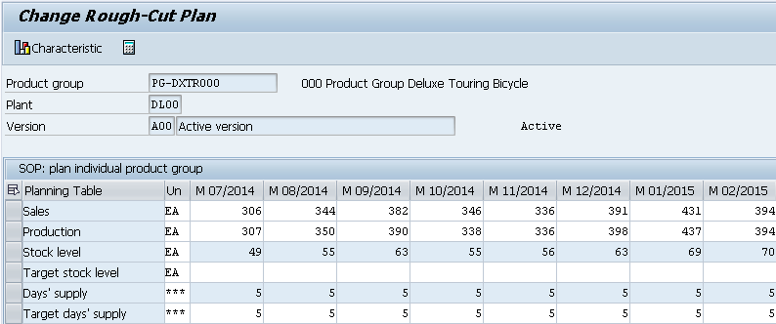
Click on to review a graphic representation of your planning table.
Note Although the screen displays integer production values, the SAP system calculates with decimal accuracy. You can display the decimal places by highlighting a row and pressing F8 and enter the amount of decimal places required. Then (re)create the production plan.
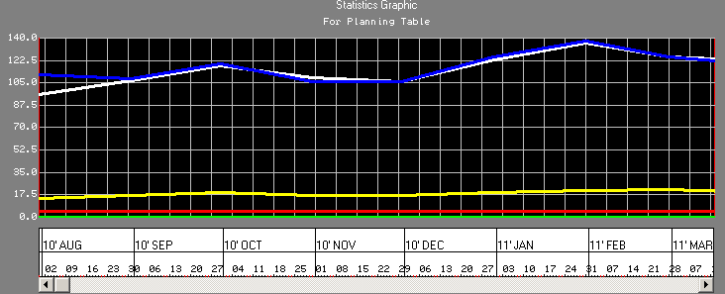
You may click on to display a legend for this graphic.
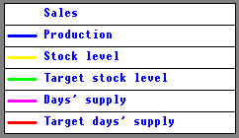
Click on to go back and save with .
Click on the exit icon to return to the SAP Easy Access screen.

 | Step 5: Transfer SOP to Demand Management
Task Transfer SOP to Demand Management. Time 10 min
Short Description Transfer the Sales and Operations Plan to Demand Management.
Name (Position) Jun Lee (Production Supervisor)
Demand Management is the tool used to disaggregate planning data from high-level plans down to the detailed planning level. For this task, planning for the Deluxe Touring Product Group will be broken down into the individual components that belong to this group. |  | Demand Management
To transfer the SOP to Demand Management, follow the menu path:  Logistics ► Production ► SOP ► Disaggregation ► Transfer PG to Demand Management |  | Menu path
Enter Product group PG-DXTR###, Plant DL00, and the version saved in the previous task (A00). |  | PG-DXTR###  DL00  A00
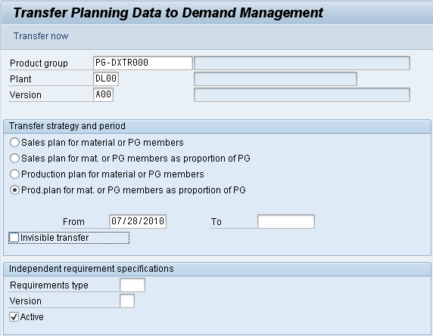
Select Prod.plan for mat. or PG members as proportion of PG and Active. Then, deselect the Invisible Transfer indicator to present the disaggregation results on another screen allowing the planner to modify the results before saving them manually to Demand Management. |  | Prod.plan for mat. or PG members as prop. of PG  Active  Invisible Transfer
Select and examine the Planned Independent Requirements generated for DXTR1###. |  | DXTR1###
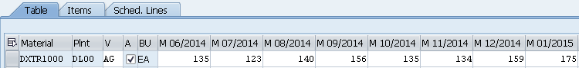
Then, click on to save.
Examine the Planned Independent Requirements generated for DXTR2### and save them with . |  | DXTR2###
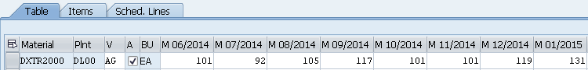
Finally, examine the requirements for DXTR3### and save them with . |  | DXTR3###
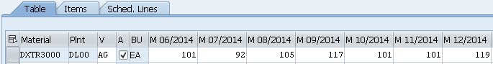
Note DXTR1### makes up 40%, DXTR2### makes up 30% and DXTR3### another 30% of the production plan created in your Sales and Operations Plan. How is this derived?

Click on the exit icon to return to the SAP Easy Access screen.

t
 | Step 6: Review Demand Management
Task Review the requirements for a product group. Time 10 min
Short Description Review the requirements for the product group to ensure that there are production requirements for the individual production items.
Name (Position) Hiro Abe (Plant Manager Dallas)
To review planned requirements, follow the menu path:  Logistics ► Production ► Production Planning ► Demand Management ► Planned Independent Requirements ► Display |  | Menu path
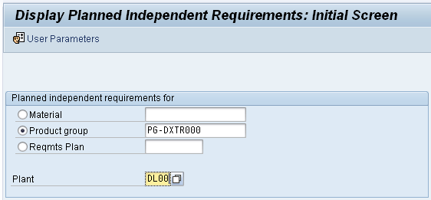
Select the Product group indicator, enter Product group PG-DXTR###, Plant DL00, and select (Enter). |  | Product group  PG-DXTR###  DL00
On the Table tab, review the Planned Independent Requirements for the Deluxe Touring bike product group by material.
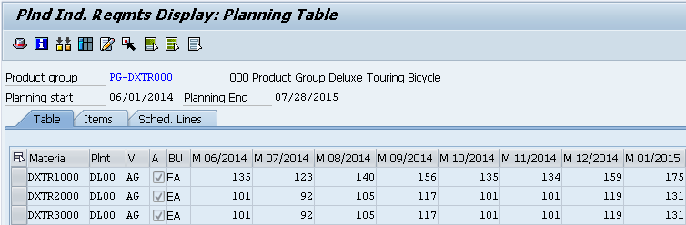
On the Sched. lines tab, review the requirement dates, planned quantities, values, and total planned quantities.
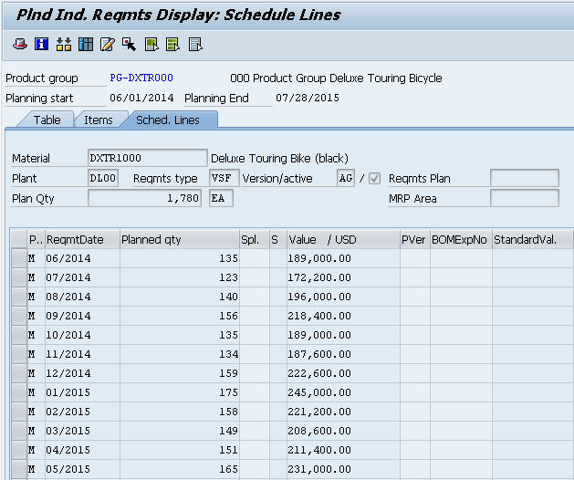
Select (Next item) to move to the next material.
Click on the exit icon to return to the SAP Easy Access screen.

 | Step 7: Run MPS with MRP
Task Run Master Production Scheduling (MPS). Time 10 min
Short Description Run Master Production Scheduling (MPS) to generate a series of planned orders that satisfy the requirements from SOP and demand management. Concurrently with MPS, the MRP materials will be processed leading to the generation of planned orders for dependent requirements that have been created by the BOM explosion process.
Name (Position) Jun Lee (Production Supervisor)
To run Master Production Scheduling, follow the menu path:  Logistics ► Production ► Production Planning ► MPS ► MPS ► Single-Item, Multi-Level |  | Menu path
Enter your material DXTR3###, Plant DL00, Processing key NETCH, select 2 (Purchase requisition in opening period), 3 (Schedule lines), 1 (MRP list), 1 (Adapt planning data (normal mode)), and 1 (Determination of Basic Dates for Planned). Then, select Display material list. |  | DXTR3###, DL00  NETCH 2  3 1  1 1  Display material list
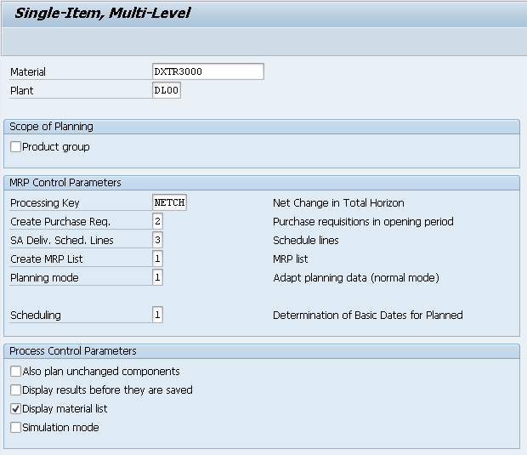
Select (Enter). A warning message will appear asking you to check input parameters. Press Enter to confirm and bypass the warning message.
To start the planning run, click on (Continue) and review the planning details from the List Display.
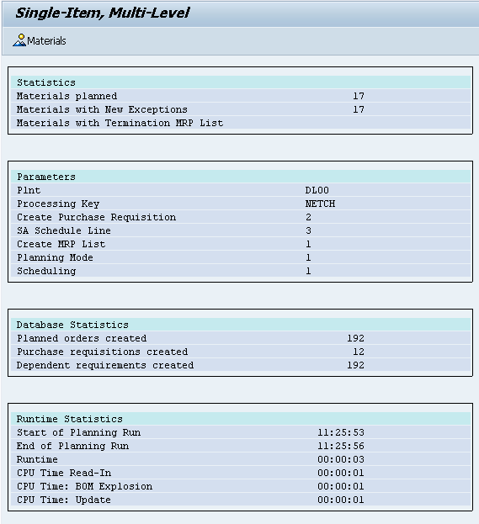
Click on the exit icon to return to the SAP Easy Access screen.

 | Step 8: Review Stock/Requirements List
Task Review the Stock/Requirements List. Time 10 min
Short Description Review the Stock/Requirements List for your deluxe touring bike.
Name (Position) Lars Iseler (Production Order Worker)
The Stock/Requirements List is a dynamic list which dynamically changes whenever a transaction occurs using the given material. Display and review the Stock/Requirements List for all materials of the red deluxe touring bike on hand and the demand that exists against these products. The report shows that there is no stock and therefore nothing is available for use at this time. |  | Stock/Requirements List
To review the Stock/Requirements List, follow the menu path:  Logistics ► Production ► Production Planning ► MPS ► Evaluations ► Stock/Reqmts List |  | Menu path
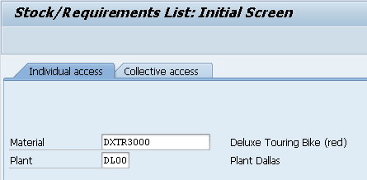
On the Individual access tab, enter Material DXTR3### and Plant DL00 and click on (Enter). |  | DXTR3###  DL00
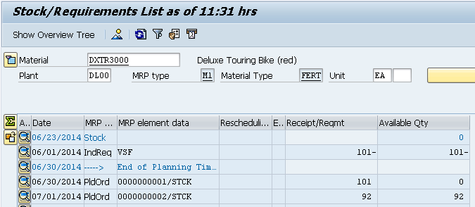
Choose (Switch to Period Totals). This will allow you to see the planned independent requirements, planned receipts, and ATP quantities based on time; days, weeks, or months.
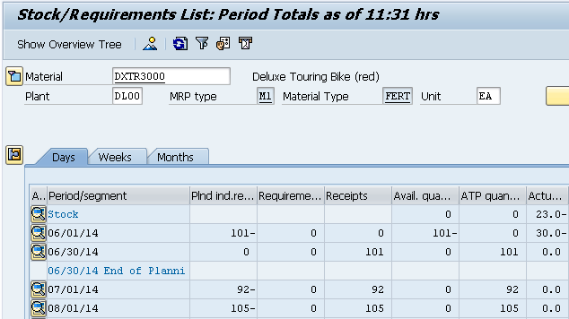
Select to go back to the individual lines.
To view the details of the first planned order (PldOrd), select (Element Details).
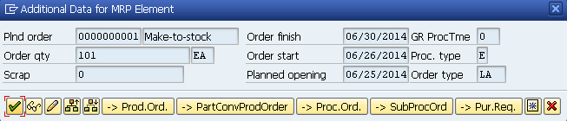
Select (Pegged Requirements).
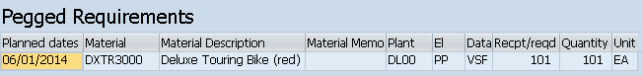
You can see that this planned order is to fulfill our Safety Stock and the first planned independent requirement that was created when we disaggregated our SOP.
Select (Graphic) to see a graphical view of this information.
Click on the exit icon twice to return to the SAP Easy Access screen.

 | Step 9: Convert Planned Order into Production Order
Task Convert a planned order into a production order. Time 10 min
Short Description Convert a planned order generated in the MPS/MRP run to a production order. The stock requirements list displays the suggested planned orders from the MPS run.
Name (Position) Lars Iseler (Production Order Worker)
To convert planned orders into production orders, follow the menu path:  Logistics ► Production ► MRP ► Evaluations ► Stock/Requirements List |  | Menu path
Enter Material DXTR3###, Plant DL00, and click on (Enter). Then, double-click on the second planned order. |  | DXTR3###  DL00
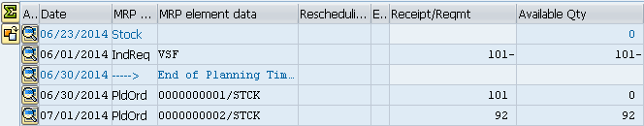
In the Additional Data screen, click on (Convert planned order to production order).
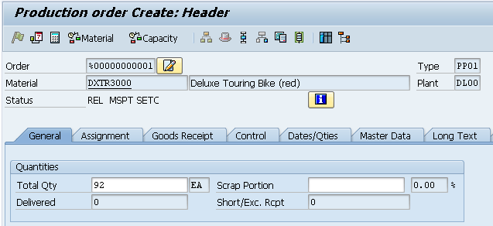
Note At this point, please note down the total quantity in your production order. You will need it later when confirming your order. |  | Total quantity  161
Determine the status of your order by clicking on . What does this mean?

Note When you converted the planned order to a production order scheduling takes place, an availability check was automatically carried out and a reservation was placed on the materials specified within the bill of materials. The order was also automatically released when the production order was created.
Click on to go back to the header screen and save your production order with .
Note When you save the production order the system will automatically calculate the planned costs for the production order and the production order is given a number.  Make sure you record your production order number. |  | Production order number
Select (Refresh) to refresh the Stock/Requirements List. In the MRP Element column the planned order PldOrd that you selected should now have changed into a production order PrdOrd.
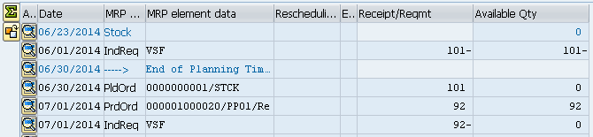
Click on the exit icon to return to the SAP Easy Access screen.

 | Step 10: Receive Goods in Inventory
Task Receive goods in the Dallas plant. Time 10 min
Short Description Receive enough goods in the Dallas storage locations to start the production process.
Name (Position) Susanne Castro (Receiving Clerk)
Usually, at this point the purchasing department in Dallas would take over and procure enough raw materials from vendors to fill the inventory so that the production process can be initiated. In this case study, we are bypassing this procurement process (this process is explained in the MM unit in detail). Because the inventory for all DXTR3### components is empty, we will assume that we find 500 pieces each in the storage location. |  | Goods receipt
To receive goods in the inventory, follow the menu path:  Logistics ► Materials Management ► Inventory Management ► Goods Movements ► Goods Receipt ► Other  Make sure you click on Other and not on Other (MIGO). This should produce the following screen. |  | Menu path
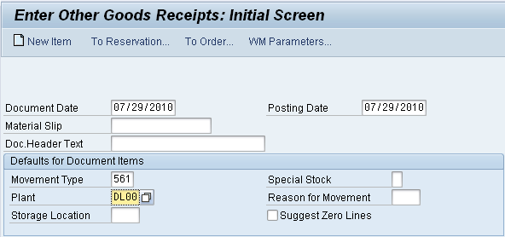
Enter today as Document and Posting Date, Movement Type 561 (Receipt per initial entry of stock balances into unr.-use), Plant DL00, and leave Storage Location blank. Then, press Enter or click on . |  | today  561  DL00
In the Enter Other Goods Receipts: New Item screen, enter the following data. Each one of these ten materials are components that you later on need in your production order. Note that all materials are stored in the raw materials storage location in Dallas except the touring wheel assembly (first component in the list) which is a semi-finished good.
 |  | TRWA1###  TRFR3###  DGAM1###  TRSK1###  TRHB1###  PEDL1###  CHAN1###  BRKT1###  WDOC1###  PCKG1###
  Material | Quantity | SLoc
  TRWA1### (Touring Aluminum Wheel Assembly) | 500 | SF00
  TRFR3### (Touring Frame-Red) | 500 | RM00
  DGAM1### (Derailleur Gear Assembly) | 500 | RM00
  TRSK1### (Touring Seat Kit) | 500 | RM00
  TRHB1### (Touring Handle Bar) | 500 | RM00
  PEDL1### (Pedal Assembly) | 500 | RM00
  CHAN1### (Chain) | 500 | RM00
  BRKT1### (Brake Kit) | 500 | RM00
  WDOC1### (Warranty Document) | 500 | RM00
  PCKG1### (Packaging) | 500 | RM00
Before pressing Enter compare your screen with the screenshot shown below. Remember that your material numbers are different.
If there are not enough rows for all materials, click on (New Items).
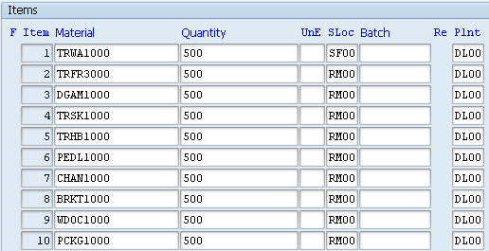
Save your goods receipt with and record the material document number. Then, click on the exit icon to return to the SAP Easy Access screen. |  | Material document number

 | Step 11: Issue Goods to Production Order
Task Issue goods to a production order. Time 10 min
Short Description Now that all necessary components are on stock issue them to your production order in precise quantity.
Name (Position) Sanjay Datar (Warehouse Employee)
The goods issue process is fully defined in the production order, BOM, and routing. The quantities and the materials are reserved for this specific production order, will be withdrawn with reference to the order number, and will be used to assign actual costs to the production order for managerial accounting purposes. |  | Goods issue
To issue goods to a production order, follow the menu path:  Logistics ► Production ► Shop Floor Control ► Goods Movements ► Goods Issue  This should produce the following screen. |  | Menu path
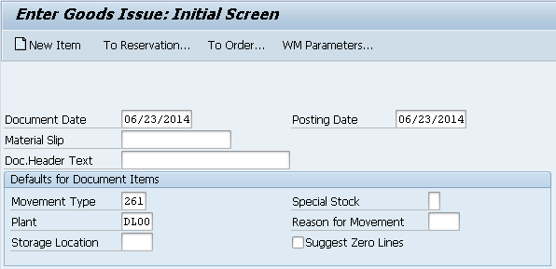
Enter today as Document Date and Posting Date, Movement Type 261 (Consumption for order from warehouse), Plant DL00, and leave Storage Location blank. Then, click on the button. |  | today  today  261  DL00
Enter your production order number from two tasks back. |  | Production order number
If you have not written down your production order number you can find it in the system. In order to do so, in the Order field press F4 or click on the search icon . In the Order Number (1) screen, use the icon on the far right to display a list of all tabs. Please select the Production orders using the info system tab. On this tab, enter your material DXTR3### in the Material field and click on . Double-click on the result row to adopt your production order number into the initial screen. |  | F4  DXTR3###
Once you have found and entered your production order number, click on to continue.
An itemized list will appear. It lists all the materials and their respective quantities that need to be issued to your order. You need to tell the system what Storage Location the materials should be withdrawn from. For the wheel assembly (TRWA1###), enter SF00 (Semi-finished goods) and for all other materials RM00 (Raw materials) in the SLoc fields. Before pressing Enter compare your screen with the one shown below. |  | SF00  RM00
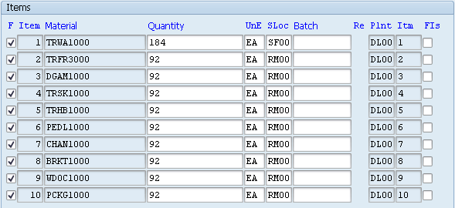
Click on the button. A series of screens will appars asking you to copy in the requirements for each of the dependent requirements. Click on to accept the details for each material.
Finally, on the Enter Goods Issue: Overview screen you will see all of the goods issue quantities for each of the materials.
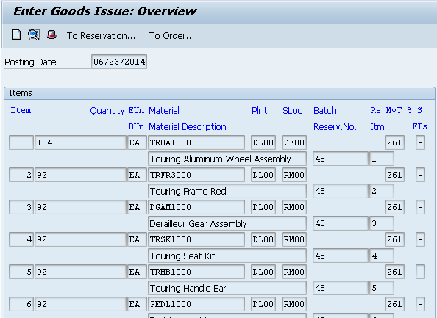
Click on (Post) and record the material document number. |  | Material document number
Click on the exit icon to return to the SAP Easy Access screen.

 | Step 12: Review Production Order Status
Task Review the production order status. Time 10 min
Short Description Review the current production order with respect to the status of the order.
Name (Position) Michael Brauer (Shop Floor Worker 4)
To display the production order, follow the menu path:  Logistics ► Production ► Shop Floor Control ► Order ► Display |  | Menu path
Enter the number of your production order. |  | Production order number
If you have not written down your production order number you can find it in the system. In order to do so, in the Order field press F4 or click on the search icon . In the Order Number (1) screen, use the icon on the far right to display a list of all tabs. Please select the Production orders using the info system tab. On this tab, enter your material DXTR3### in the Material field and click on . Double-click on the result row to adopt your production order number into the initial screen. |  | F4  DXTR3###
When your production order number is entered, click on . Note that the order status has changed and review it by clicking on again.
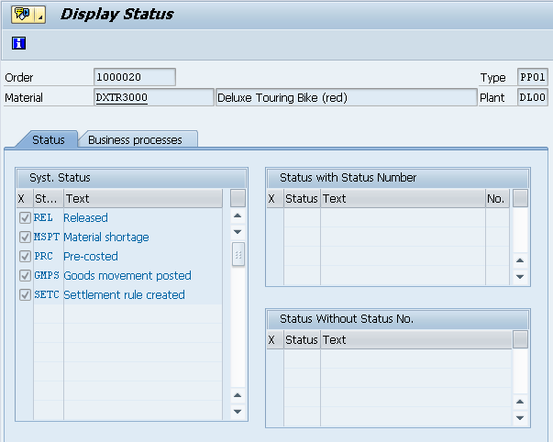
You did a goods issue to the production order in the last task. Now, you want to review the cost assigned to the order, the material document, and the corresponding accounting document.
In order to do so, click on to go back to the header screen and then in the system menu select:
Goto ► Costs ► Analysis
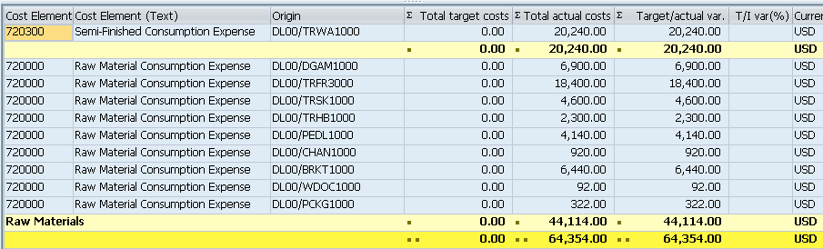
Here you can see the costs that were assigned to the production order from our goods issue.
Click on the exit icon to go back to the SAP Easy Access menu.

 | Step 13: Confirm Production Completion
Task Confirm production order completion. Time 10 min
Short Description Confirm completion for your production order.
Name (Position) Michael Brauer (Shop Floor Worker 4)
When the assembly has been completed for the current production order, we need to confirm that certain procedures and activities have been completed and record the quantity of the end product that has been manufactured. |  | Production completion
To confirm production completion, follow the menu path:  Logistics ► Production ► Shop Floor Control ► Confirmation ► Enter ► For Order |  | Menu path
Enter your production order number and click on . |  | Production order number
Select Final Confirm. and Clear Reservation. In the Yield to conf. field, enter the amount of bikes you were supposed to produce for this order. Remember that your amount might be different from the screen below. |  | Final Confirm.  Clear Reservation  Amount
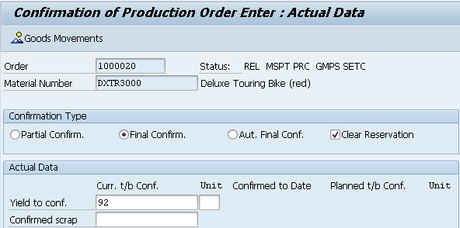
Then, change the Execution start to 1 hour earlier than the default time. |  | 1 hour earlier
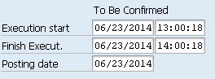
Click on and save your entries with .
Note When the confirmation is saved, labor costs for the order are calculated automatically. The quantity yield also establishes the parameters for the goods receipt into Inventory.
Click on the exit icon to return to the SAP Easy Access screen.

 | Step 14: Receive Goods from Production Order
Task Post a goods receipt from production order. Time 15 min
Short Description Post a goods receipt from your production order.
Name (Position) Susanne Castro (Receiving Clerk)
Receive the completed products into finished goods inventory. Check the quantity purposed against the quantity specified in the production order and the quantity specified during confirmation. If there are any discrepancies, the system will decide if an error or warning message should be generated depending upon the deviation identified. |  | Goods receipt
To post a goods receipt, follow the menu path:  Logistics ► Production ► Shop Floor Control ► Goods Movements ► Goods Receipt  This produces the following screen. |  | Menu path
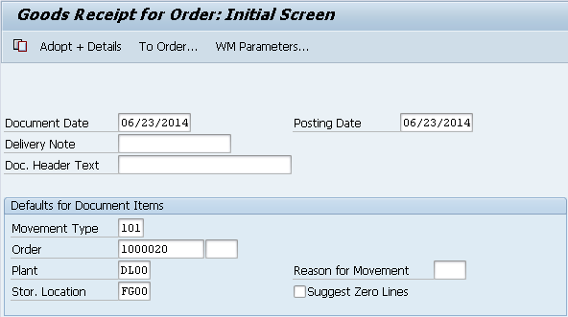
Enter Movement Type 101 (Goods receipt for order to warehouse), your production order number, Plant DL00, Stor. Location FG00 (Finished Goods), and select . |  | 101  Production order number  DL00  FG00
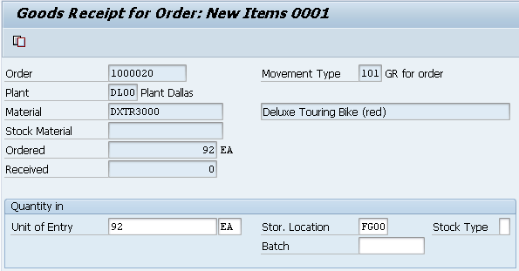
Ensure that the quantity to be placed into inventory and the storage location are correct. Then, click on to accept the details for the new bikes received from production.
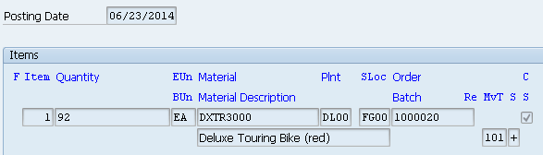
In the overview screen, review the item to ensure that all the data is correct.
- Movement Type → 101 (goods receipt into Inventory)
- Storage Location → FG00 (Inventory)
- Quantity → should equal the amount that you confirmed in the previous task
Click on to post the goods receipt. When you save this material document the actual value of the material produced was entered into the production order.  Record the material document number. |  | Material document number
Click on the exit icon to return to the SAP Easy Access screen.

 | Step 15: Review Costs Assigned to Production Order
Task Review costs assigned to your production order. Time 5 min
Short Description Display and review the costs that have been assigned to your production order.
Name (Position) Jamie Shamblin (Cost Accountant)
To display costs assigned, follow the menu path:  Logistics ► Production ► Shop Floor Control ► Order ► Display |  | Menu path
Enter your production order number, and click on (Enter). |  | Production order number
In the system menu, select:
Goto ► Costs ► Analysis
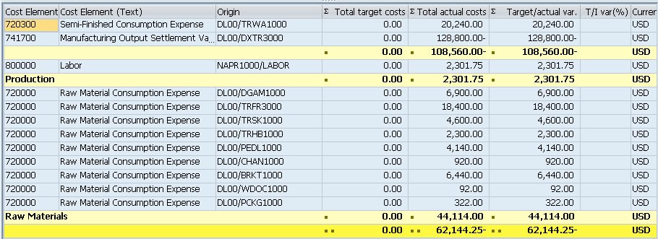
Now that the finished products have been received in the Inventory, the Manufacturing Output Settlement Variance has been added. How is this figure calculated by the system?

Click on the exit icon to return to the SAP Easy Access screen.

 | Step 16: Settle Costs of Production Order
Task Settle costs of your production order. Time 20 min
Short Description Settle the costs of your production order. The costs are temporarily captured in the production order and they need to be assigned to an appropriate cost object. Compare the actual costs to the planned costs to identify any deviations or potential problems in this regard.
Name (Position) Jamie Shamblin (Cost Accountant)
To settle costs of a production order, follow the menu path:  Logistics ► Production ► Shop Floor Control ► Period-End Closing ► Settlement ► Individual Processing |  | Menu path
If you have to input the Controlling Area, enter NA00, and click on . |  | NA00
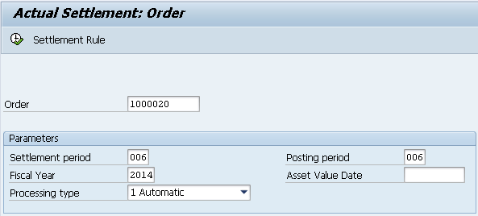
Enter your production order number, the current month as Settlement period (e.g. 007 for July), the current month as Posting period, and the current year as Fiscal year. Make sure that Test Run is selected. |  | Production order number  current month  current month  current year  Test Run
Then, click on (Execute).
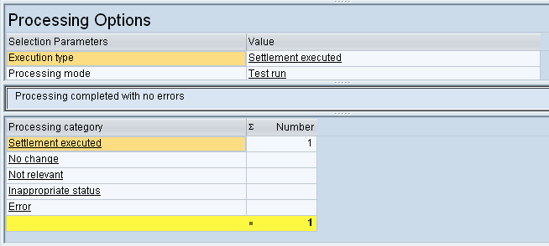
Click on (Detail lists). In the system menu, choose:  Environments ► Report  Then, double-click on Actual/Plan/Variance to select the report. |  | Actual/Plan/Variance
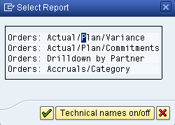
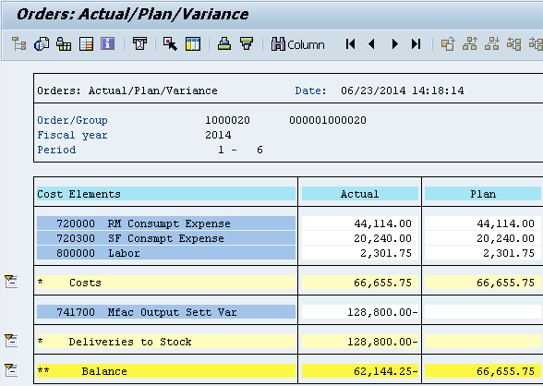
Click on to go back. Then, select and click on twice. |  | Yes
Deselect Test Run and execute again with . Click on (Detail lists) and select (Report). Choose report Actual/Plan/Variance. |  | Test Run  Actual/Plan/Variance
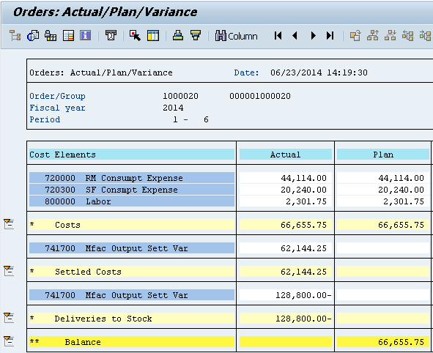
Note The manufacturing output settlement ist higher than the consumption expenses for raw materials and semi-finished goods? Review and explain the expenses and the settlements of your production order in detail. How is the balance derived?

Click on , choose and click on again to return to the SAP Easy Access screen. |  | Yes

PP Challenge
Learning Objective Understand and perform an integrated manufacturing process. Time 60 Min
Motivation After you have successfully worked through the Production Planning and Execution case study you should be able to solve the following challenge on your own.
Scenario In this challenge you should create sales and operations plan (SOP) for the product group (product family) Mountainbikes. Take into consideration that the materials of the product group have to be assigned to the strategy group. Therefore, enter manually the following sales figures:
Period | Sales (volume)
Current month + 2 | 150
Current month + 3 | 175
Current month + 4 | 200
Current month + 5 | 85
Current month + 6 | 90
Current month + 7 | 115
In addition, you must post the correct goods for Material ORMN1### in the storage location in order to be able to produce and settle costs afterwards.
Task Information Since this task is based on the Production Planning and Execution case study you can use it as guidance. However, it is recommended that you solve it without any help in order to test your acquired knowledge.

